Таблица КП «День Защитника» 23.02.2020г.
№ КП | Координаты | баллы | № КП |  | Координаты | баллы
01 | N 53 19,091  E 83 49,428 | 1 | 26 |  | N 53 19,059  E 83 49,410 | 1
02 | N 53 19,098  E 83 49,446 | 1 | 27 |  | N 53 19,170  E 83 49,635 | 3
03 | N 53 19,109  E 83 49,449 | 1 | 28 |  | N 53 19,161  E 83 49,778 | 3
04 | N 53 19,116  E 83 49,454 | 1 | 29 |  | N 53 19,188  E 83 49,782 | 3
05 | N 53 19,122  E 83 49,459 | 1 | 30 |  | N 53 19,203  E 83 49,828 | 3
06 | N 53 19,129  E 83 49,465 | 1 | 31 |  | N 53 19,216  E 83 49,820 | 3
07 | N 53 19,141  E 83 49,478 | 1 | 32 |  | N 53 19,221  E 83 49,782 | 1
08 | N 53 19,148  E 83 49,486 | 1 | 33 |  | N 53 19,130  E 83 49,259 | 1
09 | N 53 19,162  E 83 49,622 | 3 | 34 |  | N 53 19,123  E 83 49,270 | 3
10 | N 53 19,090  E 83 49,427 | 1 | 35 |  | N 53 19,233  E 83 49,763 | 1
11 | N 53 19,176  E 83 49,499 | 3 | 36 |  | N 53 19,135  E 83 49,177 | 3
12 | N 53 19,200  E 83 49,520 | 1 | 37 |  | N 53 19,178  E 83 49,197 | 1
13 | N 53 19,238  E 83 49,621 | 3 | 38 |  | N 53 19,211  E 83 49,192 | 3
14 | N 53 19,278  E 83 49,577 | 3 | 39 |  | N 53 19,234  E 83 49,126 | 3
15 | N 53 19,192  E 83 49,597 | 1 | 40 |  | N 53 19,243  E 83 49,203 | 1
16 | N 53 19,191  E 83 49,520 | 3 | 41 |  | N 53 19,249  E 83 49,277 | 3
17 | N 53 19,229  E 83 49,550 | 1 | 42 |  | N 53 19,233  E 83 49,278 | 3
18 | N 53 19,194  E 83 49,552 | 3 | 43 |  | N 53 19,180  E 83 49,273 | 3
20 | N 53 19,205  E 83 49,797 | 3 | 44 |  | N 53 19,166  E 83 49,294 | 3
21 | N 53 19,116  E 83 49,661 | 1 | 45 |  | N 53 19,158  E 83 49,308 | 3
22 | N 53 19,123  E 83 49,622 | 3 | 46 |  | N 53 19,158  E 83 49,263 | 1
23 | N 53 19,239  E 83 49,663 | 3 +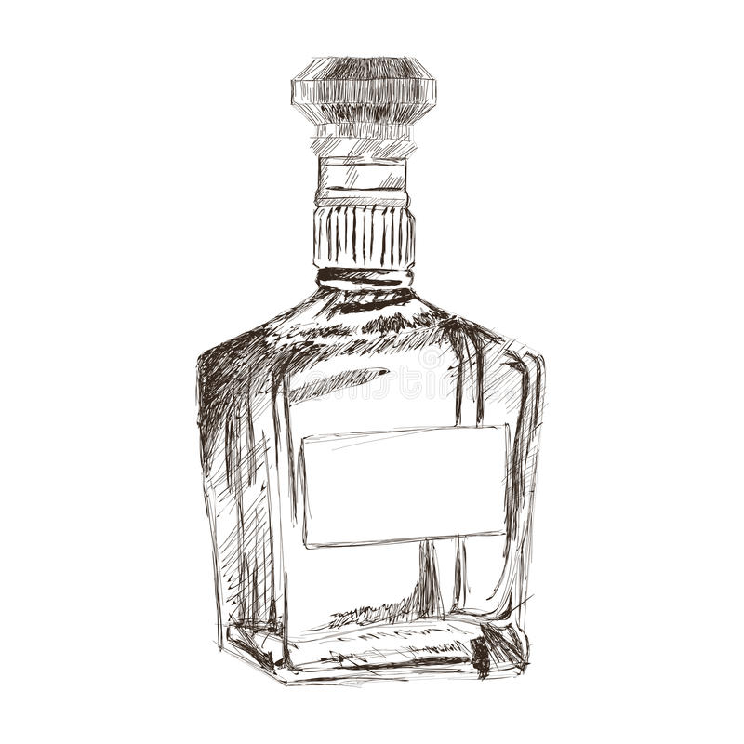 | 47 | N 53 19,154  E 83 49,252 |  | 1
24 | N 53 19,101  E 83 49,541 | 3 | 48 | N 53 19,118  E 83 49,248 |  | 1
25 | N 53 19,068  E 83 49,518 | 1 | 49 | N 53 19,111  E 83 49,243 |  | 1
Старт в 10:00ч. Финиш в 16:00ч. |  |  | 50 | N 53 19,128  E 83 49,211 |  | 1
Тел организаторов: Руководитель соревнования: Главный судья:

